Crafty Knitting Bag
This large quilted bag is perfect to hold your knitting, quilting or other crafty projects! It is easy to make, and both wide and deep enough to store all sorts of bits and pieces that you need to keep together. The inner pocket can be personalised to suit your requirements, and you may like to add a fabric measuring tape as we did too!
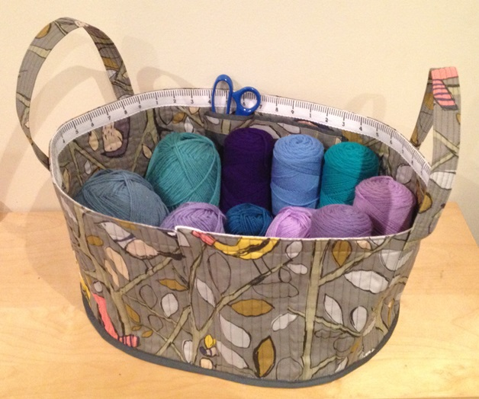 | 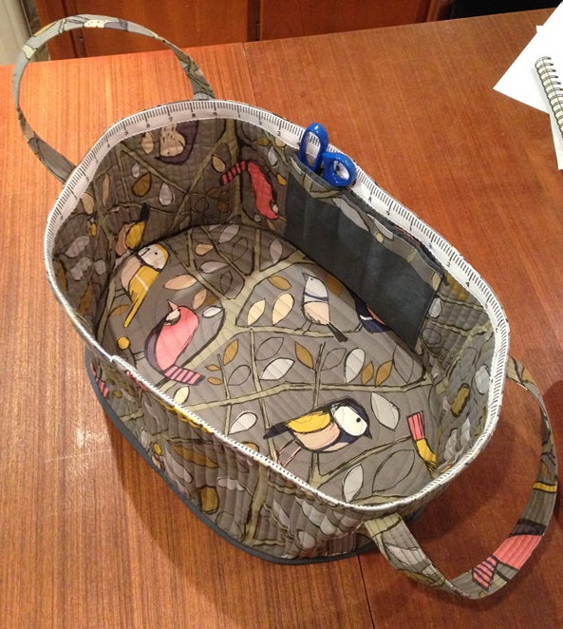
Bag Dimensions are 18 inches long x 13 inches wide and 9 inches deep.

You Will Need:
1 metre ( 1 yard) fabric for bag outer – we used cotton canvas decorator fabric that was 60 inches / 150cm wide. If using 45 inch width fabric, you will need double, and will need to join some pieces.
Approx. ¾ metre ( ¾ yard) batting
¼ metre ( ¼ yard) plain (charcoal grey) fabric for contrast pocket and binding
Small amount medium-weight fusible interfacing for pocket. (**Note - If using lighter weight fabric, we recommend you interface each piece first, before quilting, to give better stability and structure to your bag.)
Optional - 1.4 metre (54 inch) length of ribbon or woven fabric tape marked as a measuring tape

Bag Construction:
Please read all instructions fully before beginning. All measurements are in inches, and unless stated otherwise, a ¼ inch seam allowance has been used.
Referring to the attached Cutting Guide, carefully cut the required bag pieces from the bag fabrics, and batting as required. Fuse the interfacing to the wrong side of the front pocket piece.

Preparation:
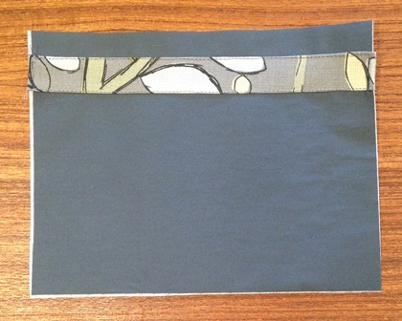 | Start with the inner pocket.  Using your iron, fold under and press a ¼ inch seam allowance down each of the long sides of the pocket contrast tab.  Position it on your front pocket piece about a ½ inch from the top, and topstitch in place.
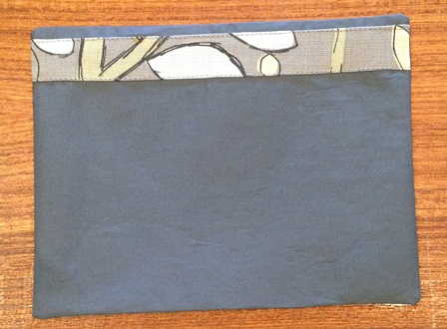 | With right sides together sew around three sides of the pocket pieces. Trim corners and turn right sides out. Tuck in the remaining seam allowances and press well.  You may find it easier to start sewing about an inch or two from one bottom corner, then sew up the side, across the top, down the other side and out another inch or so across the bottom. This gives you neat corners at the bottom, and still leaves a gap to turn pocket right sides out, after you have clipped all corners. Turn, tuck in seam allowances and press well.  Topstitch along the top edge of the pocket and put aside for now.
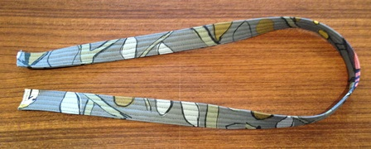 | Next make the handles. Again, using your iron, fold up and press a ½ inch seam allowance down each of the long edges of the handle strips.  Lay the batting strip down the centre, tucked under the folded edges, then fold the strip in half lengthways and pin.  Topstitch down the side to secure, and topstitch down the other side as well. Quilt a line down the centre of the handle, then quilt evenly spaced lines to either side of that, so each handle has 5 rows of stitching down the length. Put aside for now.
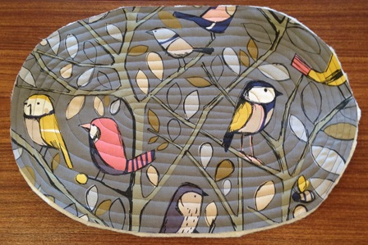 | Print the base template 4 times and stick the pages together to make your full size template.  Layer the base for quilting – one fabric panel face down, then the batting on top, and finally the remaining fabric panel on top, facing up. Smooth out and pin well before quilting the layers together. We quilted ours around in a spiral oval shape, echoing the shape of the panel.
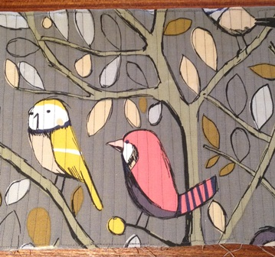 | Now quilt the sides. Fold the long strip in half, so it is 53 x 9 inches, and press to make a crease. Insert your batting between the fabric layers and pin well.  This needs to be quilted in reasonably close vertical lines to help the bag stay rigid.  It is easiest to sew a line down the centre, then down the centres of each half, to make quarters. Keep doing this in each section – sewing in half, until your lines are about a ½ inch apart. Leave about 2 inches unsewn at one end, so you can tuck in the other end when constructing the bag.

Assembly:
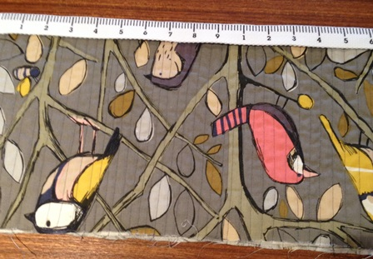 | If you are adding measuring tape to your bag, topstitch across the top and bottom of the tape, to add it to your long flat quilted sides panel. (We put ours on the inside.)  Leave about an inch extra of tape at the end you left the 2 inches un-quilted. Also make sure you stop topstitching before you reach that unsewn section.
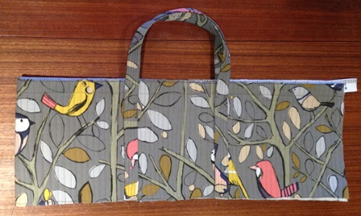 | Next add the handles. Fold the sides panel in half as shown, (with right sides out) so the raw edged ends meet.  Measure in about 9 inches from the folded side, and position your handle so the halves are 6 inches apart. Align bottom edges and pin in place.  Turn the panel over and repeat to position the second handle.  Topstitch up the sides of the handles and across the top on the lower stitched tape line.
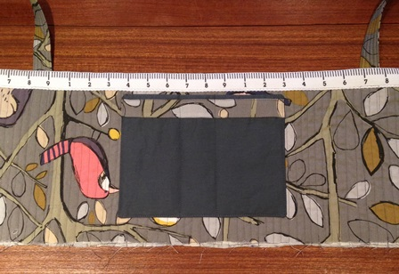 | Finally, add the pocket.  Centre it between the handles on the inside of the panel, and so it sits just under the tape as pictured.  Pin in place and topstitch down the sides and across the bottom.  Personalise your pockets – we sewed 2 lines through the pocket to make 3 pockets, for scissors and crochet hooks/knitting needles.
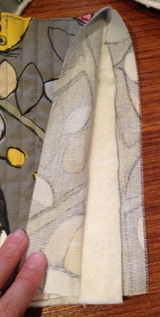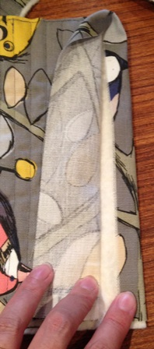 | At the end you left un-quilted, trim away about an inch of the batting as shown.  Tuck in the seam allowances and pin the end closed. Tuck in the excess tape too.  Now measure this sides strip around your quilted base to double check that it is the correct size.  If needed, trim excess fabric away from the other end of this long panel.
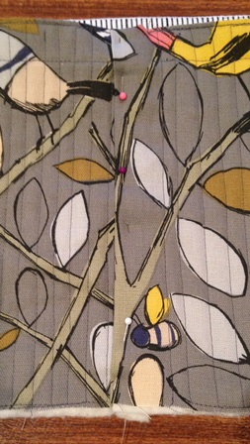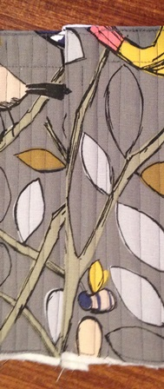 | Insert the raw edged end of this strip into the end with the folded seam allowances as shown.  Re-pin and topstitch down the edge to secure all layers and join your strip into a circle.  Quilt extra lines as required so that your join matches the rest of the sides panel.
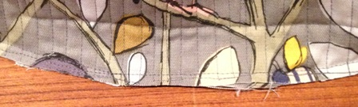 | With wrong sides together, pin the sides to the base, so that the raw edges meet and the sides are centred with the handles on each smaller end of the oval base.  Sew the panels together.
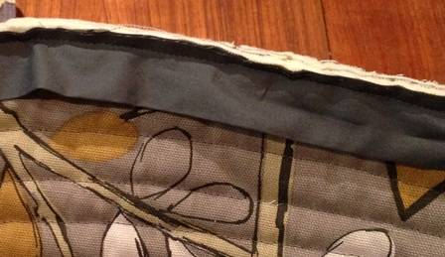 | Bind that bottom seam with the contrast binding.  Sew the binding to the oval base side, so that raw edges meet.
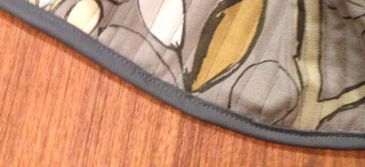 | Finally, flip to the binding over to the top side and pin and machine sew it down, to neatly cover the seam.  Now fill with your current craft project and enjoy!

Crafty Knitting Bag Cutting Guide
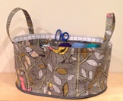 | Cut the required number of each piece according to the measurements on each diagram.  * Please note – all measurements are in inches.
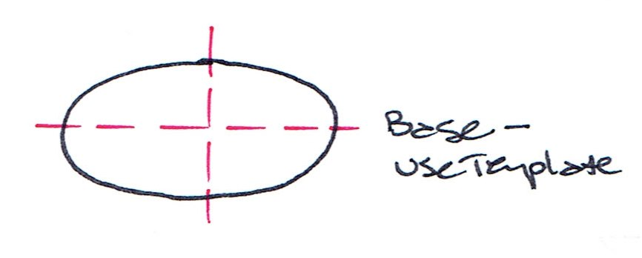  Base – Use Template | Cut 2 outer fabric  Cut 1 batting  *Print 4 of this template page and cut and join together down the dotted centre lines, for a full sized template.
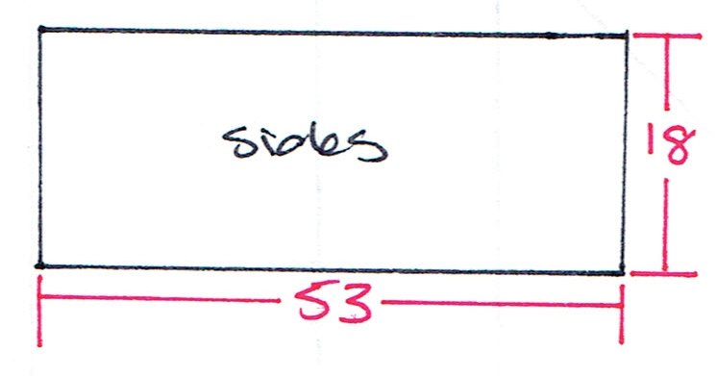  Sides | Cut 1 outer fabric  Cut 1 batting – 9 inches wide
Handles  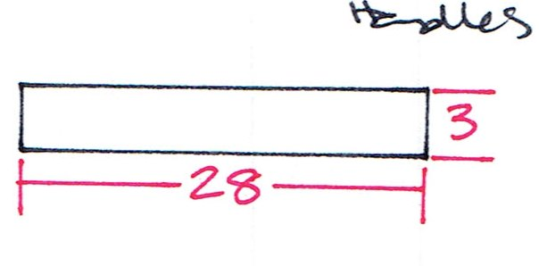 | Cut 2 outer fabric  Cut 2 batting – 1¾ inches wide
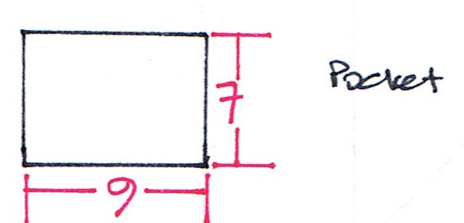  Pocket | Cut 2 contrast fabric  Cut 1 medium-weight interfacing
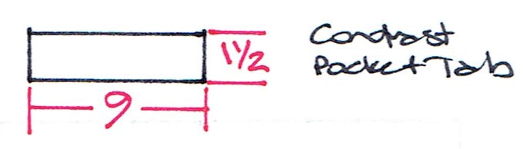  Contrast Pocket Tab | Cut 1 outer fabric
Binding  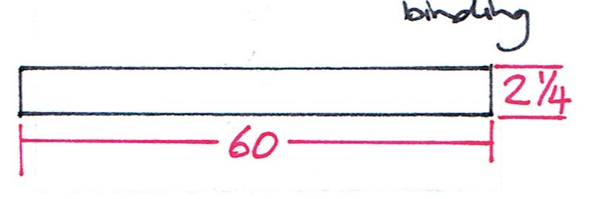 | Cut 1 contrast fabric

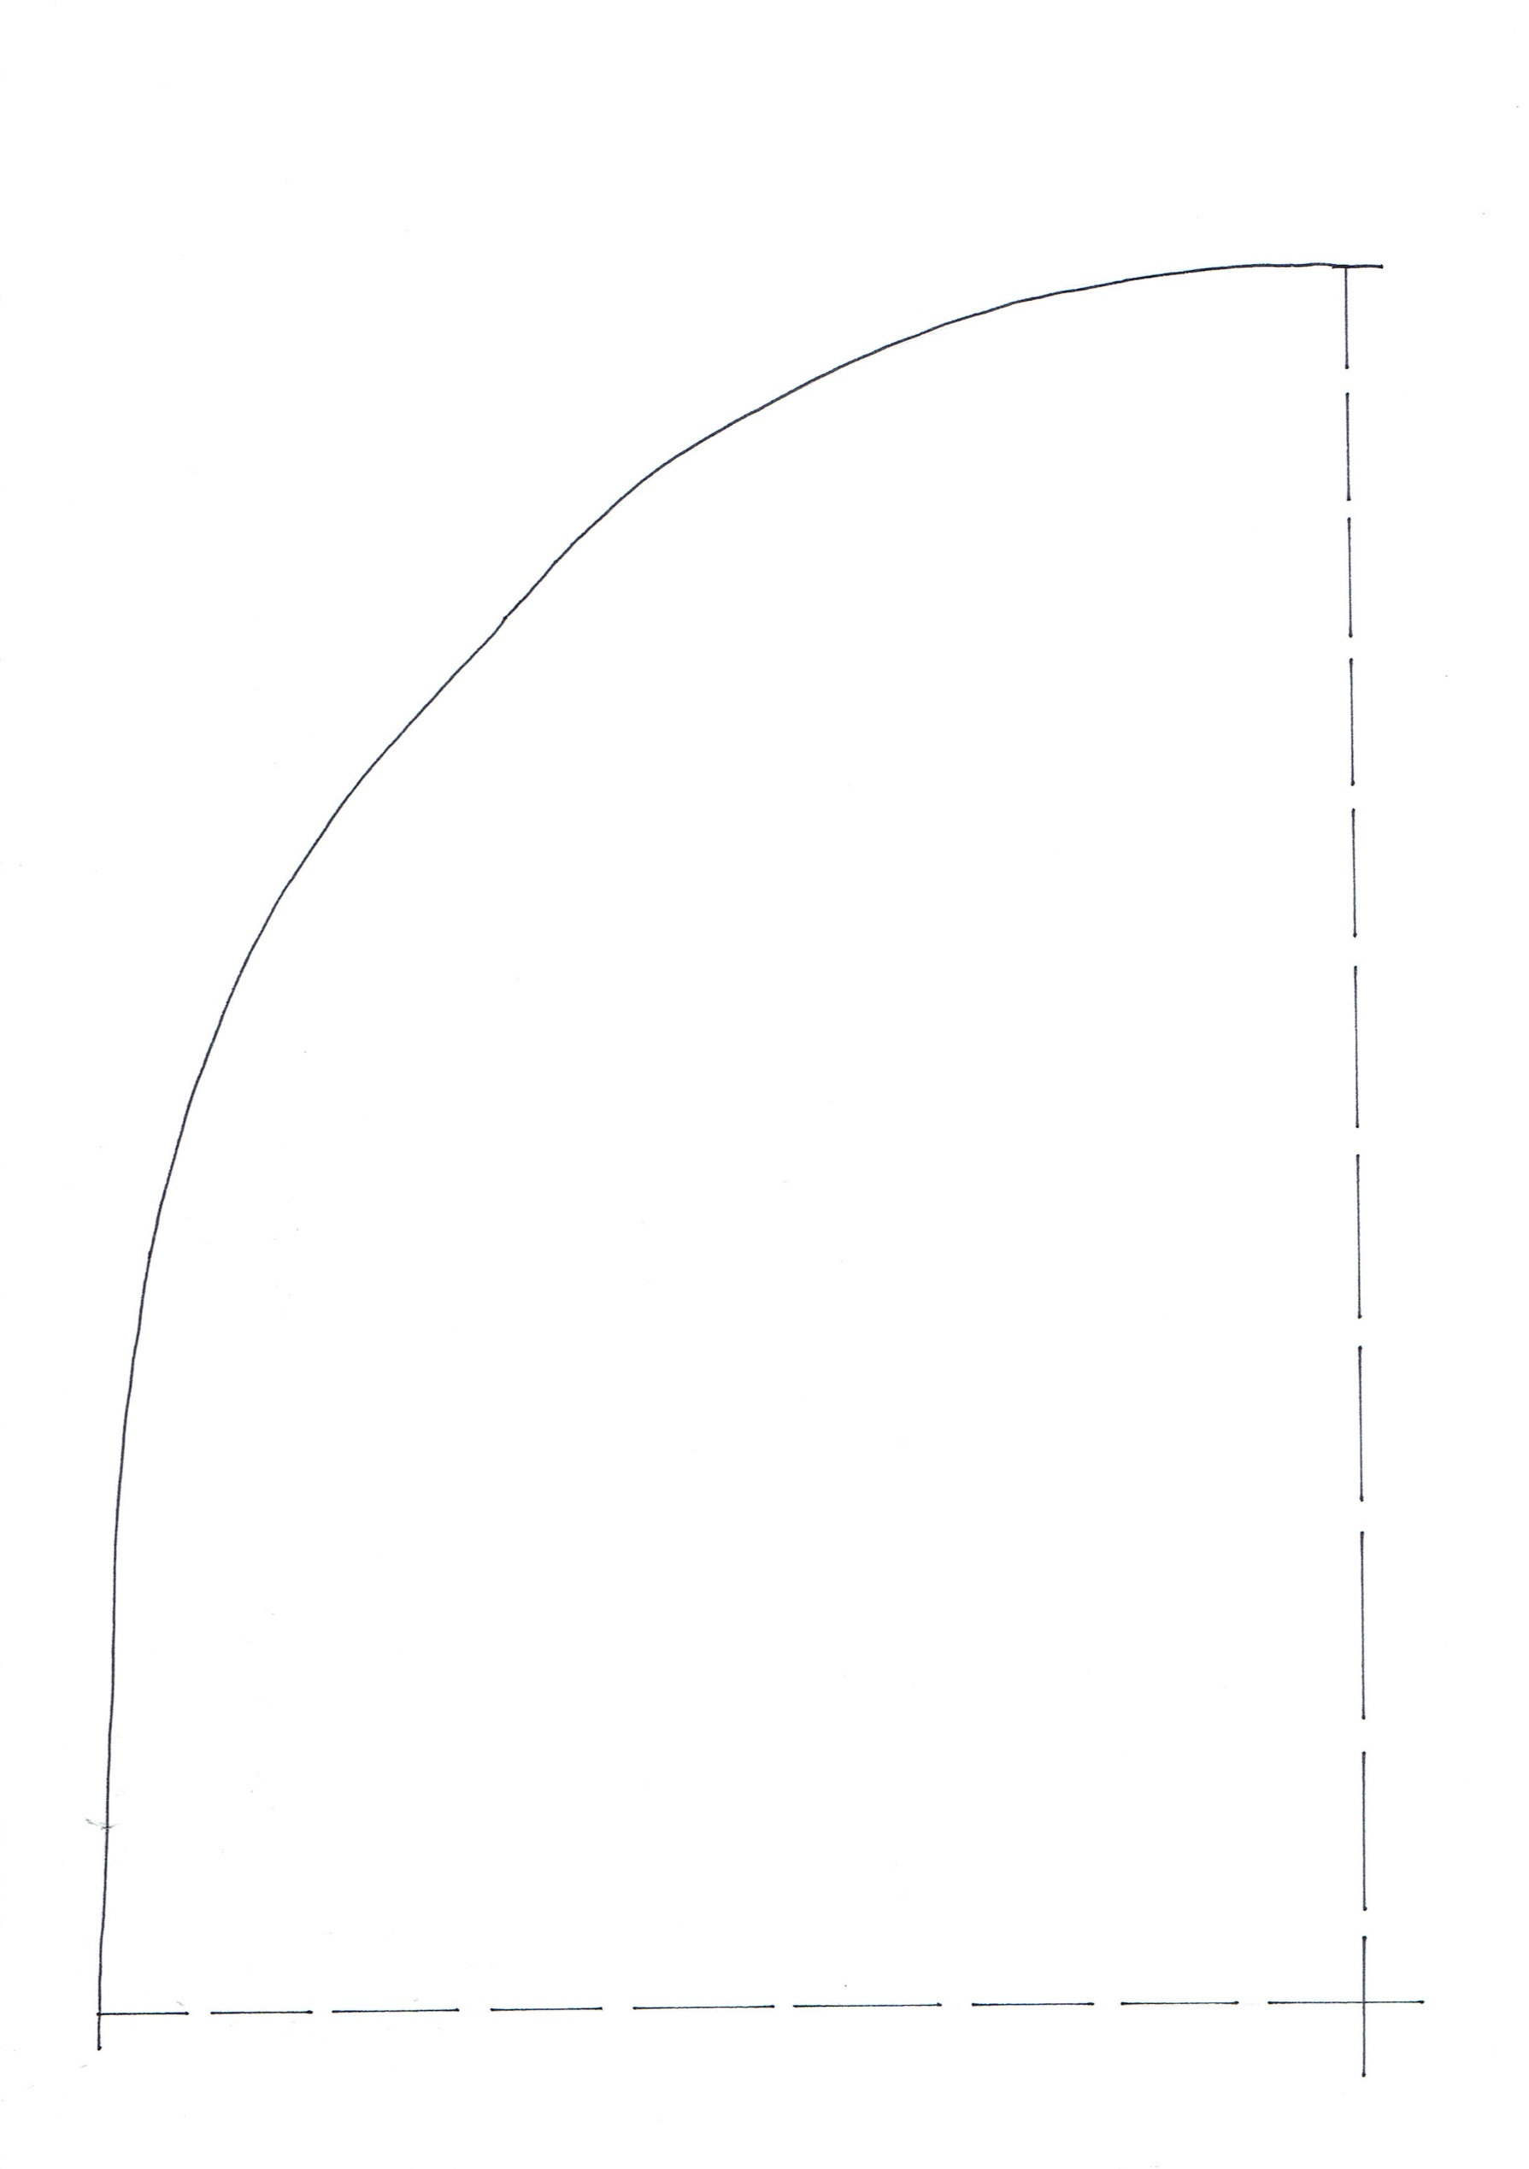

Crafty Knitting Bag
Base Template
*Print 4 and join together on the dotted lines for a full size template*
©3DollarQuiltBOM.com

